Bank Marketing Campaign Analysis and

Term Deposit Subscription Prediction

1. Project Overview
This project focuses on analyzing the Bank Marketing Campaign dataset using Python to identify factors influencing customer subscription to term deposits. The analysis includes data cleaning, feature engineering, exploratory data analysis (EDA), statistical analysis, and data visualization to uncover customer behavior and campaign performance.
The project aims to convert raw banking data into meaningful insights that help improve marketing strategies, identify potential customers, and support data-driven business decision-making.

2. Data Source
Source: UCI Machine Learning Repository https://archive.ics.uci.edu
Location: Portuguese banking institution.
Year/Timeline: Data collected from May 2008 to November 2010 during multiple direct marketing (telephone) campaigns.
Domain: Banking, Finance, Direct Marketing, Customer Relationship Management (CRM).

3. Problem Statement
The bank faces low conversion rates and high marketing costs when promoting term deposit products. The goal is to analyze customer and campaign data to identify potential subscribers and optimize future marketing efforts through predictive analytics.

4. Objectives

- To analyze customer demographics (age, job, marital status, education) and their impact on term deposit subscription.
- To identify the financial factors (balance, housing loan, personal loan, credit default) that influence customer decisions.
- To evaluate the effectiveness of previous marketing campaigns using variables such as contact type, call duration, campaign contacts, previous contacts, and previous campaign outcomes.
- To discover which customer segments have the highest probability of subscribing to a term deposit.
- To identify the key features that most strongly influence subscription decisions.
- To generate business insights and recommendations to improve future marketing campaigns and increase conversion rates while minimizing marketing costs.

Expected outcome
- Identify the key customer characteristics that influence term deposit subscription.
- Discover the most effective marketing campaign strategies and communication channels.
- Determine the factors that positively and negatively impact customer conversion.
- Segment customers based on their likelihood of subscribing to a term deposit.
- Develop a predictive model that accurately identifies potential subscribers.
- Provide actionable business recommendations to improve campaign targeting and increase conversion rates.
- Help the bank reduce unnecessary marketing costs by focusing on high-potential customers.
- Enable data-driven decision-making to improve the effectiveness and return on investment (ROI) of future marketing campaigns

5. Attribute (Column / Feature) Details
Attribute Name | Description
Age | Age of the customer in years.
Job | Customer's occupation or profession.
Marital_Status | Marital status of the customer (Married, Single, Divorced).
Education | Highest education level of the customer.
Credit_Default | Indicates whether the customer has credit in default (Yes/No).
Balance | Average yearly account balance in Euros.
Housing_Loan | Indicates whether the customer has a housing loan (Yes/No).
Personal_Loan | Indicates whether the customer has a personal loan (Yes/No).
Contact_Type | Communication method used to contact the customer (Cellular, Telephone, Unknown).
Last_Contact_Day | Day of the month when the customer was last contacted.
Contact_Month | Month in which the last contact was made.
Call_Duration | Duration of the last marketing call in seconds.
Call_Duration_Min | Duration of the last marketing call converted into minutes. (Derived Feature)
Campaign_Contacts | Number of contacts made with the customer during the current marketing campaign.
Days_Since_Previous_Contact | Number of days since the customer was last contacted in a previous campaign. A value of -1 indicates the customer was not previously contacted.
Previous_Contacts | Number of contacts made before the current campaign.
Previous_Outcome | Outcome of the previous marketing campaign (Success, Failure, Other, Unknown).
Subscription | Target variable indicating whether the customer subscribed to the term deposit (Yes/No).

6.Tools & Technologies
- Python
- Pandas
- NumPy
- Matplotlib
- Seaborn
- Google Colab
- Jupyter Notebook

7.Project Workflow
Business Understanding
↓
Data Collection
↓
Data Cleaning
↓
Feature Engineering
↓
Statistical Analysis
↓
Exploratory Data Analysis
↓
Business Insights
↓
Recommendations

8. Data Pre-Processing and Feature Engineering
The dataset was prepared for analysis using data preprocessing techniques.
Data Exploration
Explored the dataset by checking its dimensions, column names, data types, duplicates, missing values, and summary statistics to understand the data quality
Data Cleaning Steps
- Renamed the columns to improve readability
- Checked data types of all columns
- Identified missing values
- Handled null values
- Handled some unknown values wherever appropriate.
- Removed duplicate records
- Corrected inconsistent data
- Converted data types where required

Feature Engineering
New features were created to improve data analysis and customer segmentation.
- Age Group – Created from Age to classify customers into different age categories.
- Balance Level – Created from Balance to group customers based on account balance.
- Customer Type – Created based on Balance Level to classify customers into different customer segments.
- Campaign Level – Created from Campaign Contacts to categorize customers based on the number of campaign contacts.
- Call Duration (Minutes) – Created by converting Call Duration from seconds to minutes for better readability.

9. Analysis and Visualizations
The dataset was analyzed using Exploratory Data Analysis techniques to understand patterns and relationships.

10. Exploratory Data Analysis (EDA)
Initial inspection included:
- Data frame structure verification
- Statistical summary of numerical columns
- Null value verification
- Duplicate record validation
EDA helped in understanding the distribution and characteristics of the data.

11. Statistical Analysis
Statistical measures were used to summarize the dataset.
Measures included:
- Mean
- Median
- Mode
- Minimum value
- Maximum value
- Standard deviation
These measures helped understand the central tendency and variability of the data.

12. Data Visualization
Visualization techniques were used to represent data graphically and make patterns easier to understand.

1. Univariate Analysis
Analyzed each variable individually to understand customer distribution."
.Analysis Performed:

1. Subscription Distribution
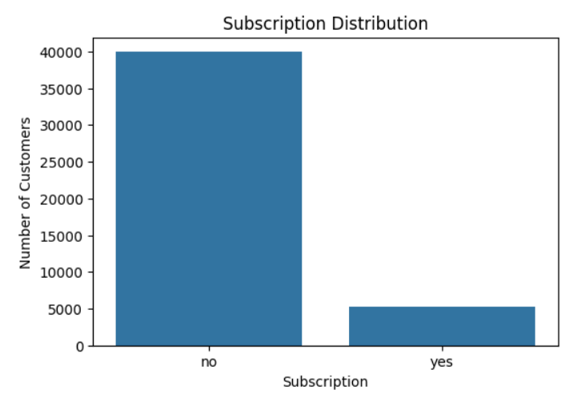
Interpretation: The dataset is highly imbalanced, with approximately 88% of customers not subscribing and only about 12% subscribing to the term deposit.

2. Distribution of Call Duration

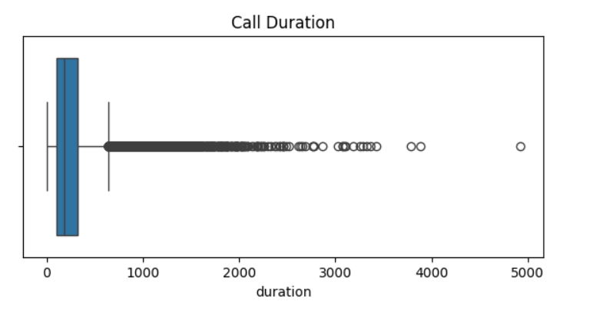
Interpretation: Most marketing calls are of short duration, while only a few calls last for a longer time.

3. Distribution of Account Balance
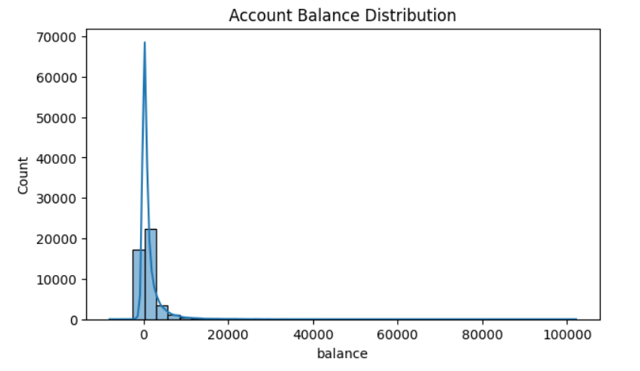
Interpretation: Most customers have low to moderate account balances, while a small number have very high balances.

2. Bivariate Analysis
Bivariate analyzed how different variables affect subscription.
Analysis Performed:
1. Age Group vs Subscription
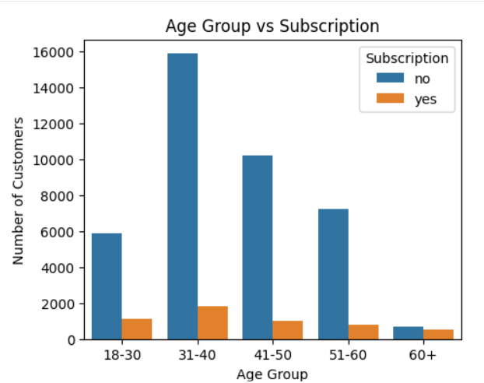
Interpretation: Middle-aged customers have the highest subscription rate, while younger and older age groups show comparatively lower subscriptions.
2. Occupation vs Subscription
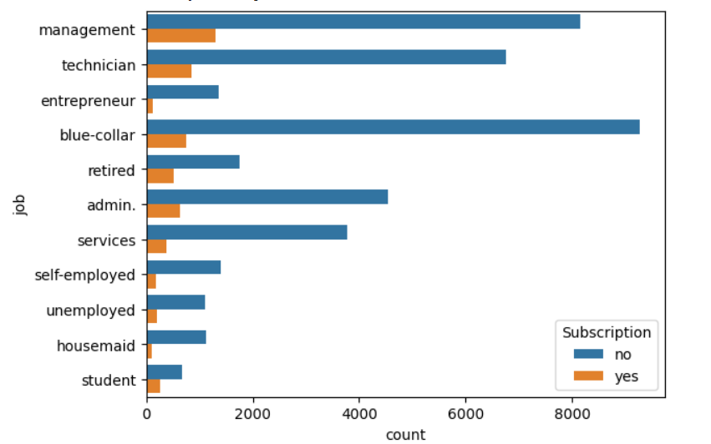
Interpretation: Subscription rates vary across occupations, with some job categories responding more positively to the marketing campaign.
3. Balance vs Subscription
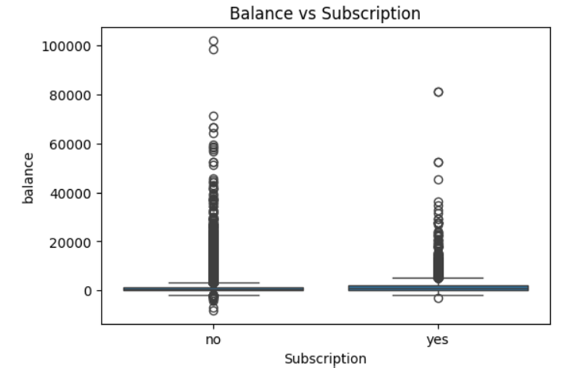
Interpretation: Customers with higher account balances are more likely to subscribe to the term deposit than those with lower balances.
4. Housing Loan vs Subscription
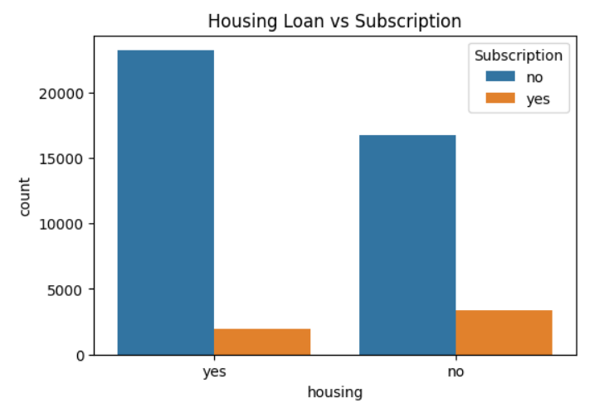
Interpretation: Customers without a housing loan have a higher subscription rate than customers with a housing loan.
5. Duration vs Subscription
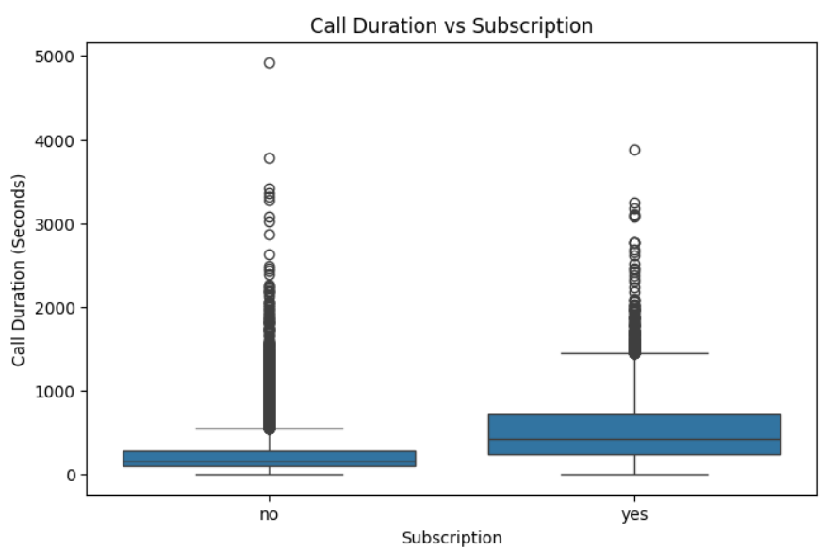
Interpretation: Customers with longer call durations are more likely to subscribe, indicating that call duration has a strong influence on subscription.

3. Multivariate Analysis
Multivariate analysis was used to analyze relationships among multiple variables.
Analysis Performed:
1. Pair Plot of Numerical Variables
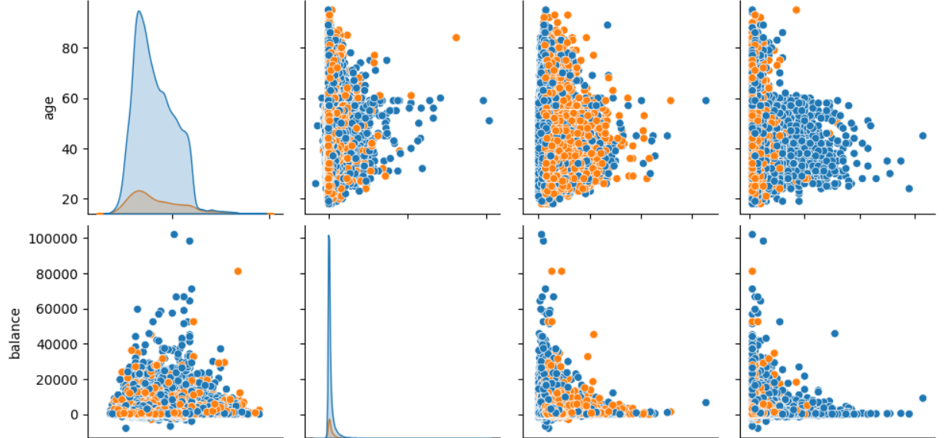 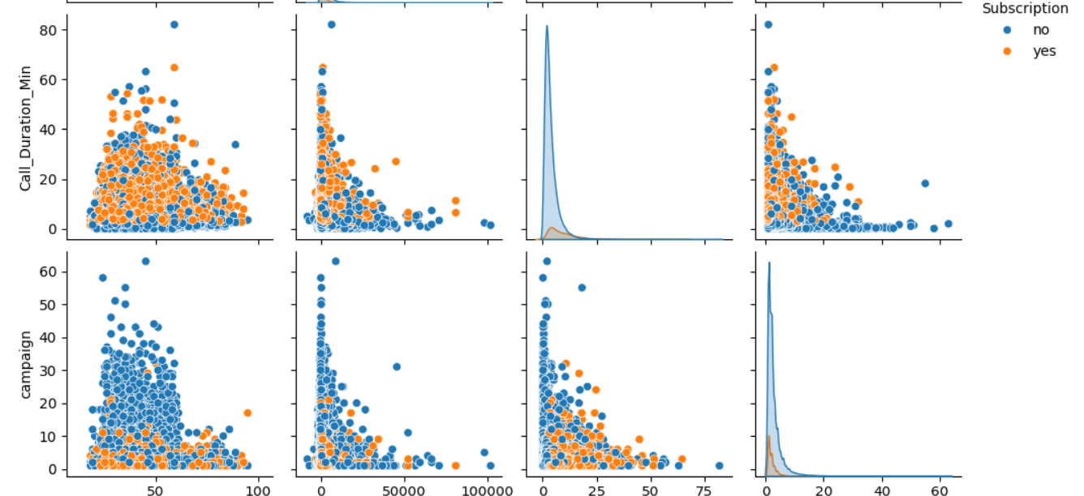Interpretation: The pair plot shows the relationships and distribution of numerical variables such as Age, Balance, and Call Duration. It helps identify patterns, trends, and possible correlations between these variables.
2. Heatmap of Age Group vs Balance Level vs Subscription Rate
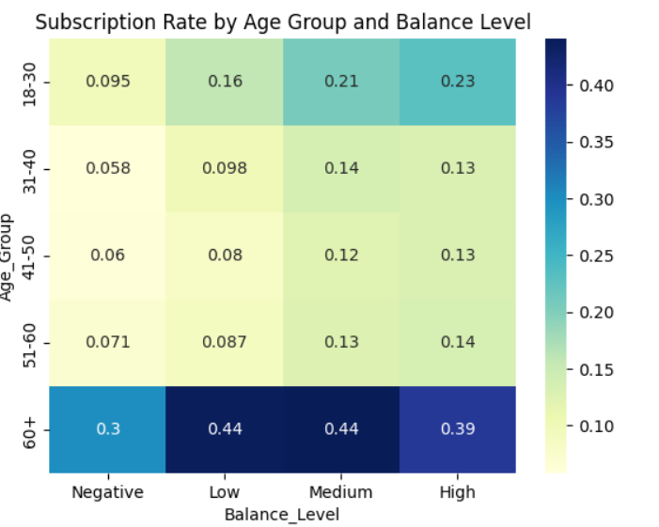
Interpretation: The heatmap highlights the subscription rate across different age groups and balance levels. Customers with higher account balances in certain age groups show relatively higher subscription rates.

13. Summary of Findings
- The dataset is imbalanced , most customers belong to the middle-age group.
- Short-duration calls are the most common, while longer calls have a higher subscription rate.
- Customers with higher account balances are more likely to subscribe to the term deposit.
- Middle-aged customers contribute the highest number of subscriptions.
- Subscription rates vary across different occupations, indicating occupation influences customer response.
- Customers without a housing loan show a higher subscription rate than those with a housing loan.
- The pair plot indicates relationships among numerical variables, with call duration showing the strongest association with subscription.
- Previous successful campaign outcomes significantly improve future subscription probability.
- The heatmap reveals that subscription rates differ across combinations of Age Group and Balance Level, with higher-balance customers in certain age groups showing better subscription rates.
- Overall, Age Group, Account Balance, Occupation, Housing Loan Status, and Call Duration are the key factors influencing term deposit subscription.

14. Types of Analysis
1. Descriptive Analysis
Descriptive analysis summarizes historical data.
Analysis Performed:
- Analyzed the distribution of Age, Account Balance, and Call Duration.
- Examined the distribution of term deposit subscriptions.
- Created Age Group, Balance Level, and Campaign Level to summarize customer characteristics.

2. Diagnostic Analysis
Diagnostic analysis explains why certain outcomes occurred.
Analysis Performed:
- Analyzed the relationship between Age Group and Subscription.
- Studied how Occupation, Account Balance, Housing Loan, and Call Duration influence subscription.
- Used a heatmap to identify how Age Group and Balance Level together affect subscription rates.

3. Predictive Analysis
Predictive analysis helps forecast future outcomes.
Analysis Performed:
- Identified key features such as Call Duration, Balance, Age Group, and Housing Loan for predicting term deposit subscriptions.
- Prepared the dataset for building a subscription prediction model.

4. Prescriptive Analysis
Prescriptive analysis recommends actions based on insights.
Suggested Actions:
- Target customers with higher account balances for future campaigns.
- Focus marketing efforts on customer segments with higher subscription rates.
- Increase customer engagement through longer and more effective calls.
- Design personalized campaigns based on age group, occupation, and loan status.

15. Future Enhancements and Suggestions
This analysis suggests that the bank should:
- Focus on customers with higher subscription probability.
- Improve campaign targeting management .
- Doing camp on IT employees about financial awareness
- Reduce repeated unsuccessful contacts.
- Use predictive models for customer selection.
- Focus marketing efforts on high-potential customer segments.
- Prioritize customers with successful previous campaign outcomes.
- Improve customer data quality.
- Use customer segmentation for personalized marketing.

16. Conclusion
This project successfully analyzed the Bank Marketing dataset using Python and performed data preprocessing, feature engineering, and exploratory data analysis. Various visualizations helped identify key factors influencing term deposit subscriptions, including age group, account balance, occupation, housing loan status, and call duration. The insights obtained can support banks in improving marketing strategies, targeting the right customers, and increasing subscription rates.

